**SALES ORDER REPORT DOC**

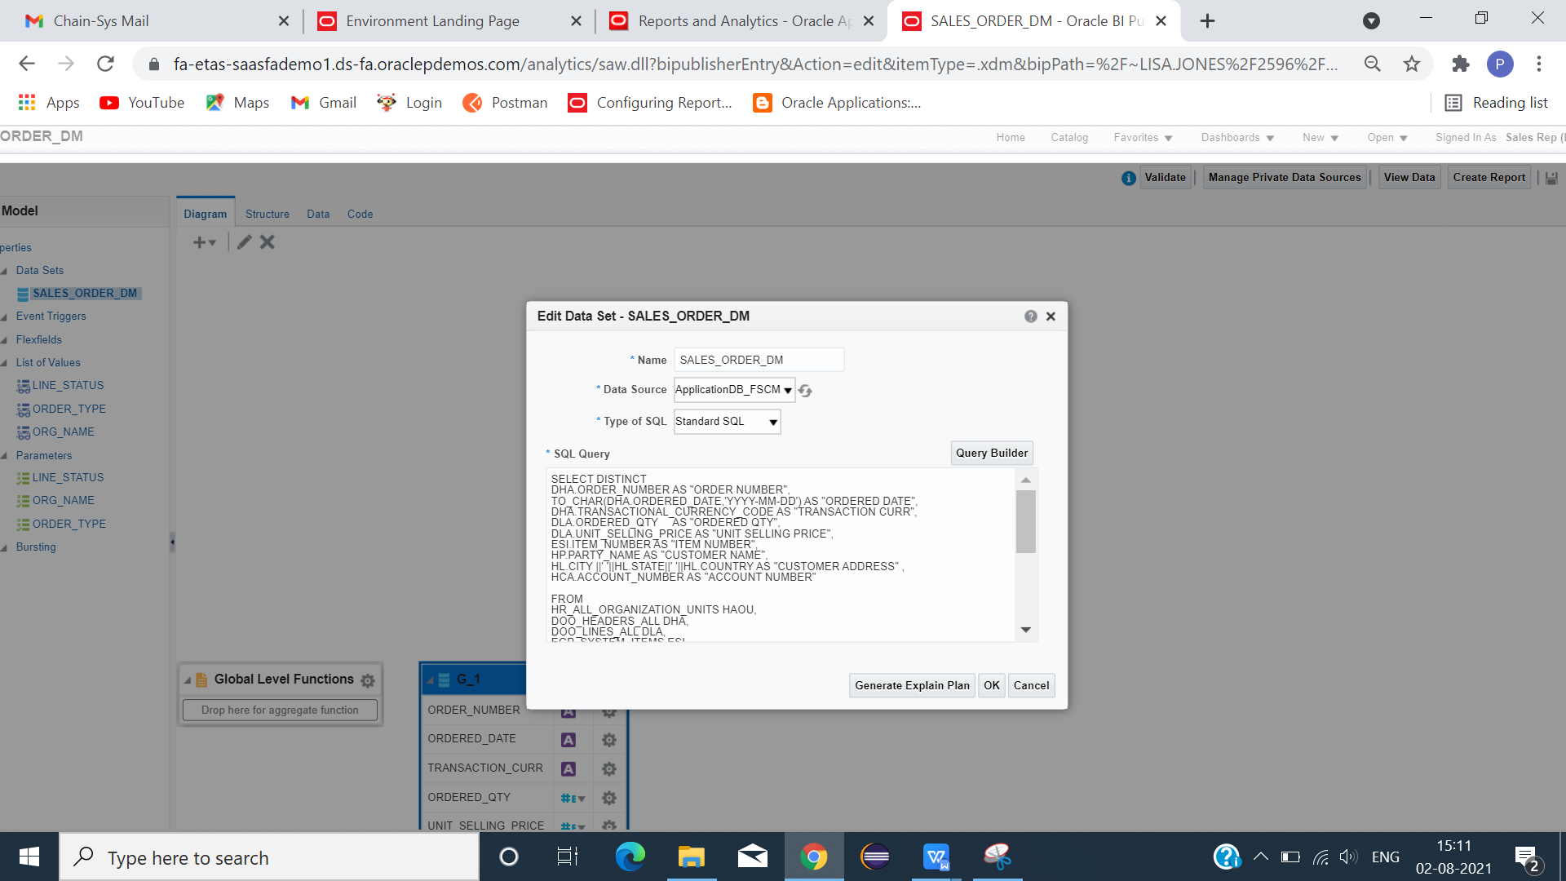

CLICK -> NEW -> DATAMODEL.

TYPE AP AGING QUERY.

**DATA MODEL QUERY**

SELECT DISTINCT

DHA.ORDER_NUMBER AS "ORDER NUMBER",

TO_CHAR(DHA.ORDERED_DATE,'YYYY-MM-DD') AS "ORDERED DATE",

DHA.TRANSACTIONAL_CURRENCY_CODE AS "TRANSACTION CURR",

DLA.ORDERED_QTY AS "ORDERED QTY",

DLA.UNIT_SELLING_PRICE AS "UNIT SELLING PRICE",

ESI.ITEM_NUMBER AS "ITEM NUMBER",

HP.PARTY_NAME AS "CUSTOMER NAME",

HL.CITY ||' '||HL.STATE||' '||HL.COUNTRY AS "CUSTOMER ADDRESS" ,

HCA.ACCOUNT_NUMBER AS "ACCOUNT NUMBER"

FROM

HR_ALL_ORGANIZATION_UNITS HAOU,

DOO_HEADERS_ALL DHA,

DOO_LINES_ALL DLA,

EGP_SYSTEM_ITEMS ESI,

HZ_PARTIES HP,

HZ_CUST_ACCOUNTS HCA,

HZ_PARTY_SITES HPS,

HZ_LOCATIONS HL

WHERE 1=1

AND HAOU.ORGANIZATION_ID = DHA.ORG_ID

AND DHA.HEADER_ID = DLA.HEADER_ID

AND DLA.INVENTORY_ITEM_ID = ESI.INVENTORY_ITEM_ID

AND DHA.SOLD_TO_PARTY_ID = HP.PARTY_ID

AND DHA.SOLD_TO_CUSTOMER_ID = HCA.CUST_ACCOUNT_ID

AND DHA.SOLD_TO_PARTY_ID = HPS.PARTY_ID

AND HPS.LOCATION_ID = HL.LOCATION_ID

AND HAOU.NAME = NVL( :ORG_NAME,HAOU.NAME)

AND DHA.ORDER_TYPE_CODE = NVL( :ORDER_TYPE,DHA.ORDER_TYPE_CODE)

AND DLA.STATUS_CODE = NVL( :LINE_STATUS,DLA.STATUS_CODE)

**PARAMETERS**

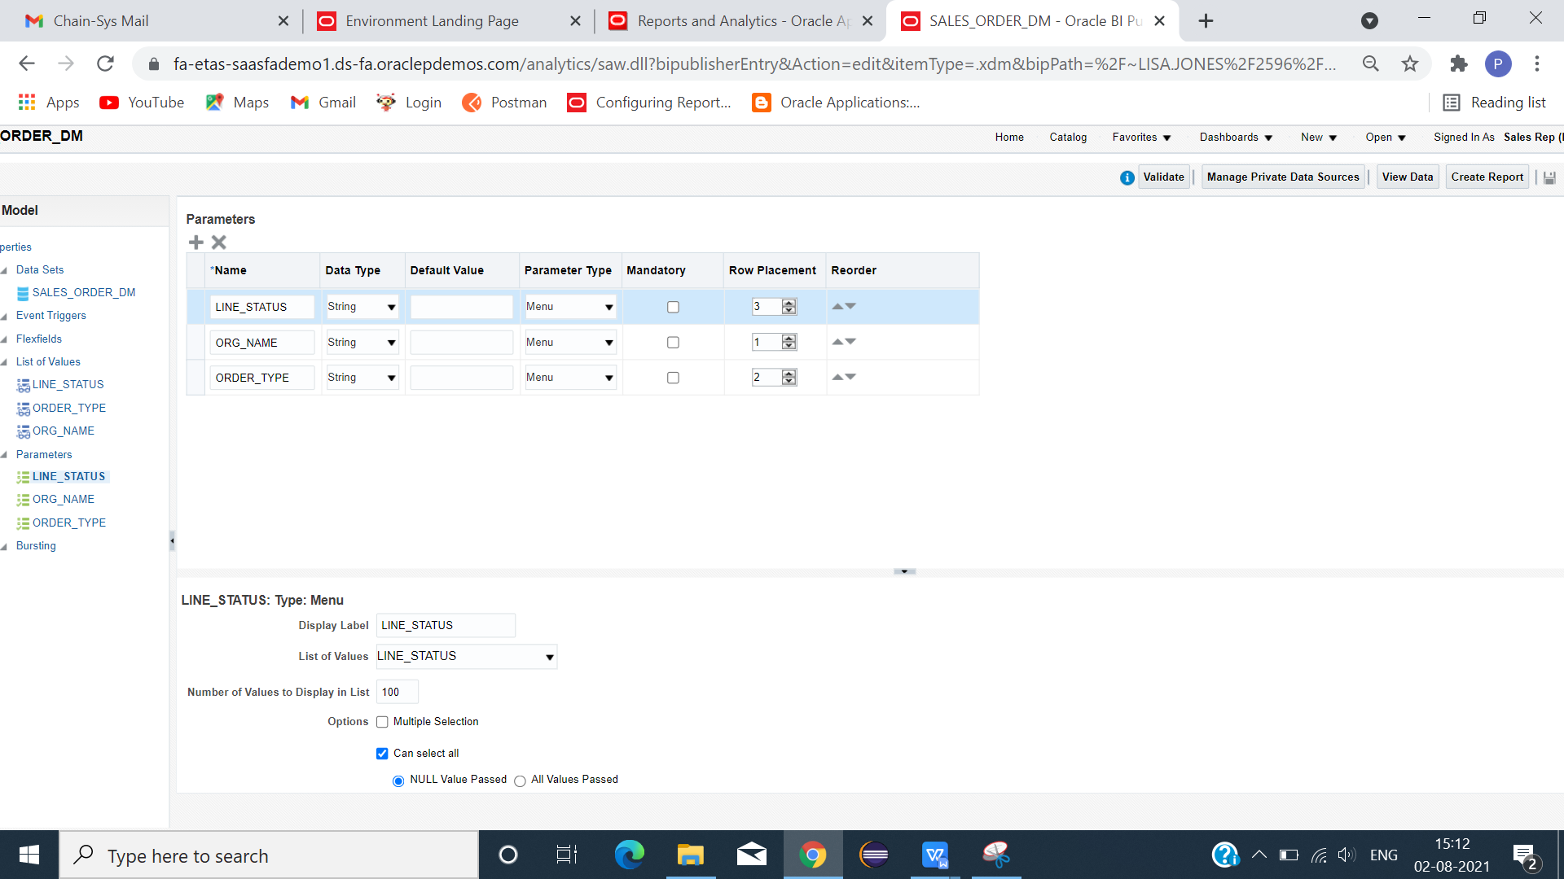

**LIST OF VALUES QUERY**

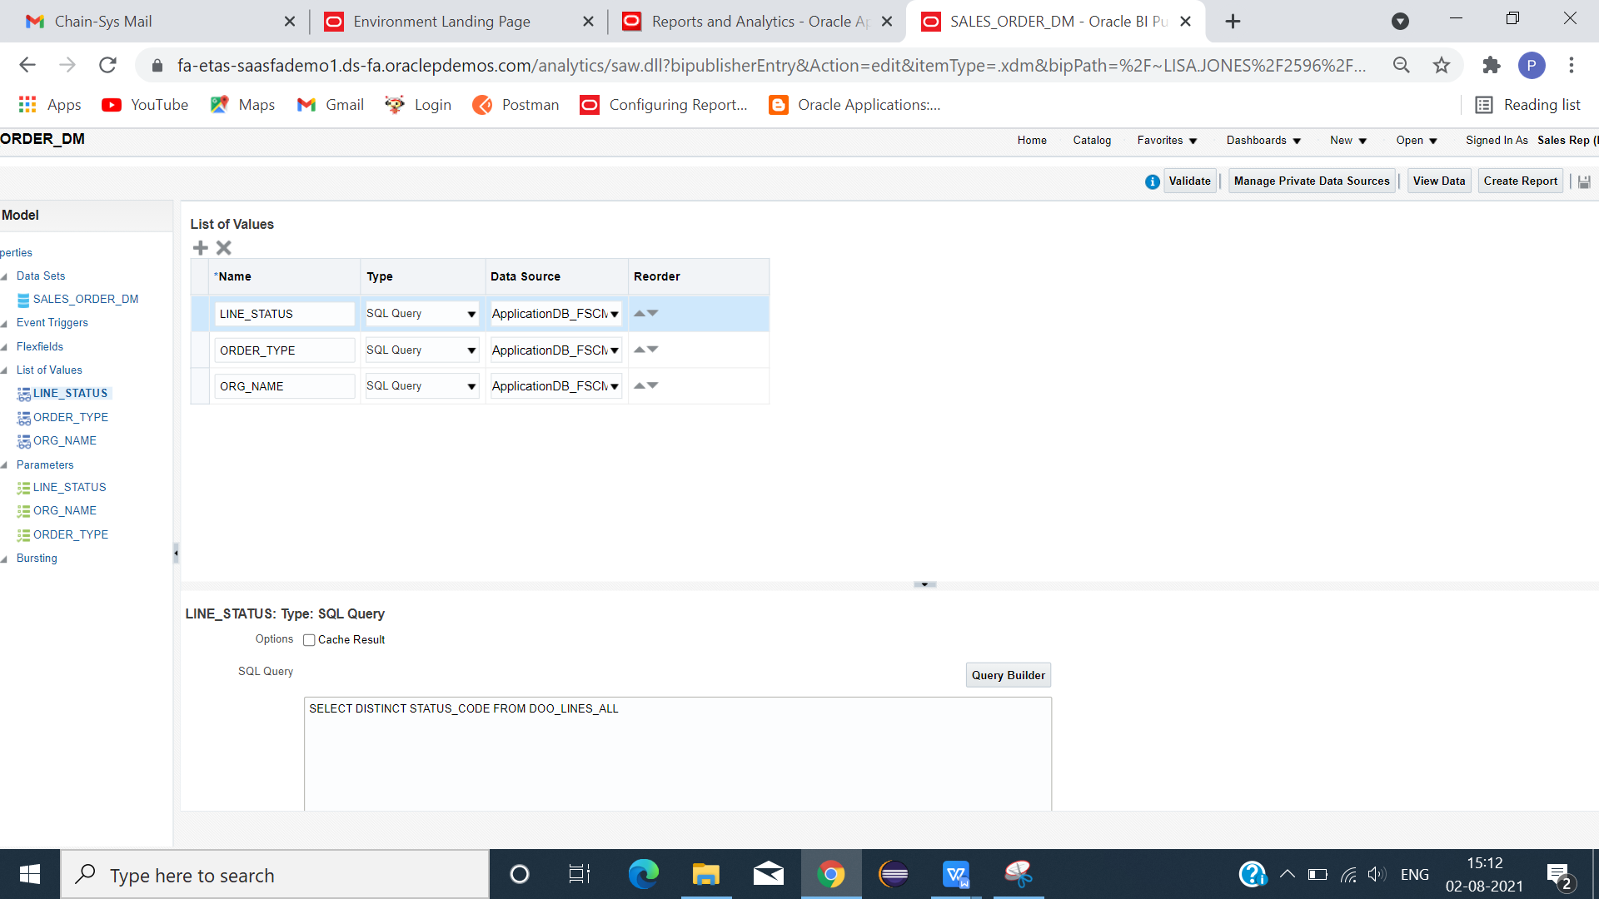

**LINE_STATUS:**

**SELECT DISTINCT STATUS_CODE FROM DOO_LINES_ALL**

**ORDER_TYPE:**

**SELECT DISTINCT ORDER_TYPE_CODE FROM DOO_HEADERS_ALL**

**ORG_NAME:**

SELECT DISTINCT NAME FROM HR_ALL_ORGANIZATION_UNITS

WHERE NAME IN ('France Business Unit','US1 Business Unit','China Business Unit','UK Business Unit')

CLICK DATA -> SAVE -> VIEW -> VIEW SAMPLE DATA -> SAVE -> EXPORT(XML FILE).

**EXCEL TEMPLATE**

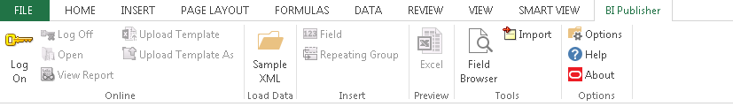

CLICK SAMPLE XML(LOAD DATA) - > LOAD XML FILE -> FIELD(META DATA CREATED) .

INSERT COLUMNS USING FIELDS(PARAMETER AND REQUIRED COLUMNS).

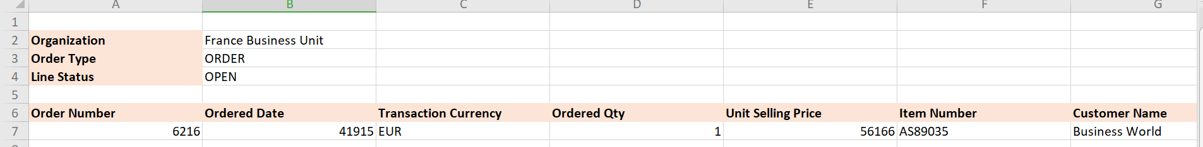

SAVE TEMPLATE AS (EXCEL 2003 WORKBOOK) FORMAT.

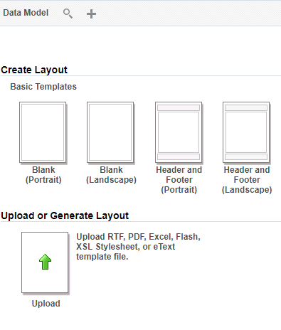

LOAD DATA MODE -> CLICK UPLOAD OR GENERATE LAYOUT.

GIVE LAYOUT NAME -> LOAD TEMPLATE -> CHOOSE TEMPLATE FORMAT -> LOCALE -> OK

SAVE -> REPORT -> RUN

REPORT SUCCESSFULLY GENERATED IN EXCEL FORMAT.

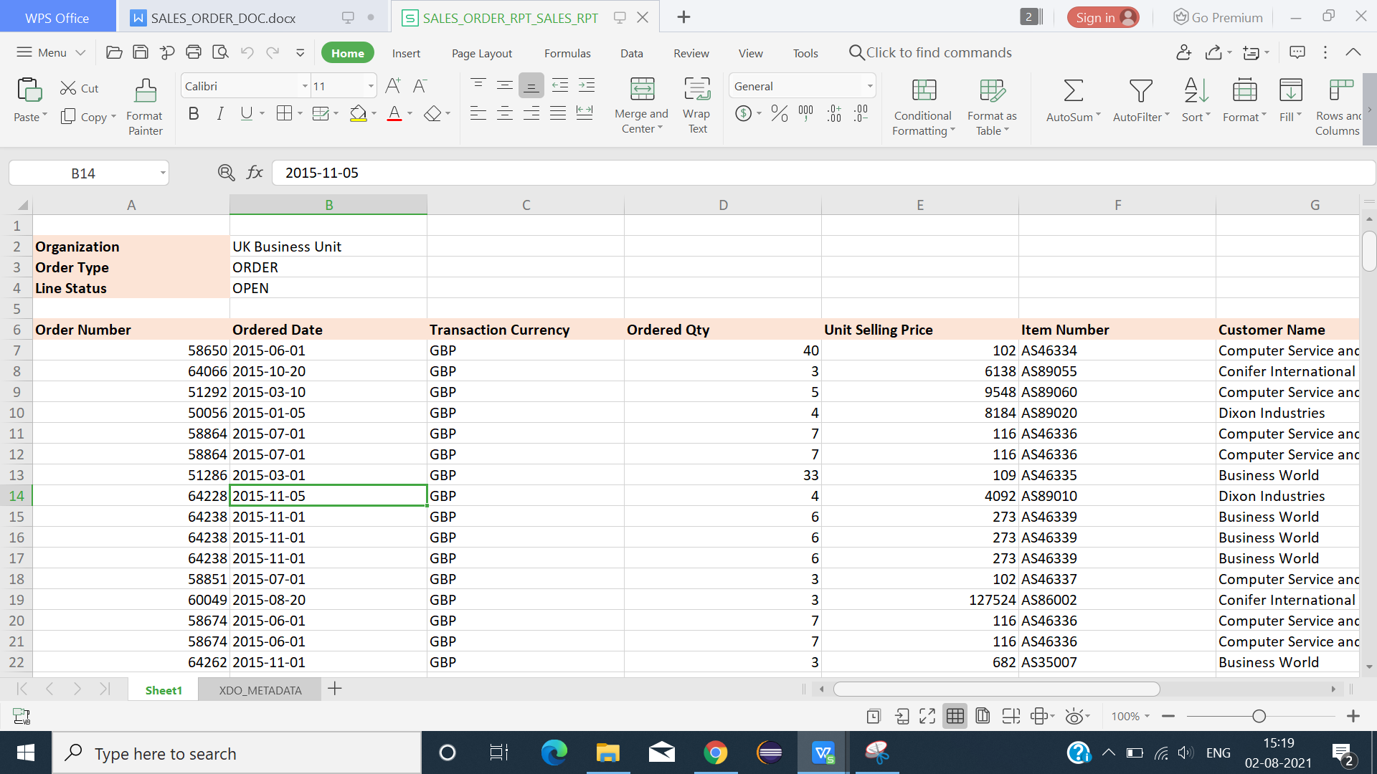

FINAL OUTPUT RESULT IN EXCEL FORMAT.

===================================================================================